**Guideline – Insert Client Logo**

**Guideline –Template**

Sasha stepanov

BCDE311 – Software Development PROJECT

Semester 1, 2023

<Project NAME> for <CLIENT NAME>

Project Proposal

Version <version number>

Contents

Introduction 5

Project Details 6

Project Name 6

Overview of Industry Client 6

Project Background 6

Information Gathering 7

Documentation 7

Project Scope 8

Project Goal(s) 8

Benefits of Project 8

Project Requirements 8

Expected Deliverables 8

User Personas 8

Project Plan – High Level 9

Project Management Framework adopted 9

Phases 9

Timetable 9

Burndown Charts 9

Resources/Access Required 9

Risk Management 10

Approach 10

Risk Table 10

Quality Assurance 11

Approach 11

Quality Assurance Table 11

Test Plans – Functional and Usability 11

Project Management Framework Methodology 12

Overview 12

Literature Review 12

Critique (Pros and Cons) 12

Ethics 13

Relevance of ITP Code of Ethics 13

Relevant Legislation 14

Reflections 15

Approach 15

Specifications 16

Reference List 17

Appendices 18

Appendix A – Detailed Project Plan 18

Appendix B – Risk Management Table 18

Appendix C – Quality Assurance Table 18

Document Control

|  |  |  |  |
| --- | --- | --- | --- |
| Date | Author | Version | Status of Document/Updates Made |
| 05/03/2023 | Sasha Stepanov | v0.1 | Document Creation |
| dd/mm/yyyy | Sasha Stepanov | v0.2 etc |  |
| dd/mm/yyyy | Sasha Stepanov | v1.0 | Signed Off, Submitted |

# Introduction

This proposal provides information about software development project for an IT industry client. Proposal contains all the information and documentation regarding the project and its components that has been collected to meet the projects goals. The document is divided into several parts which will provide information about the project, specifically:

• Project details, scope size, information about the project client and future users

• Client interview and interview transcription

• Timeline and phases of a project

• Risk management plan

• Details of the chosen methodology and framework

• Quality assurance plan for functional and usability testing

• Ethics overview.

# Project Details

This section will help to understand the basics of the future project and the desires of the client.

## Project Name

“Virtual prospection” – Virtual orientation.

## Overview of Industry Client

Currently, the client has a team for results processing, marketing and only developers are missing. The client hires developers to create a successful Ara Virtual Tour.

## Project Background

### The main idea of the project is an informative resource for existing students and attracting new applicants.

### Overview

Leaping into the unknown is not an easy task, so visualization comes to the rescue. A professionally made virtual tour will not only help you navigate the area, but also help you advertise your business. It helps to create the effect of presence, the illusion of an excursion. Bright, memorable visual images will help to leave a good impression of the product or service.

The second equally important part of the project is the display of students' work in the form of posters.

### Current Situation

At the moment, there are already virtual tours for Ara, which are used for new students. The time has come to update them, as interest in the virtual tour, as well as in the Faculty of ICT, is declining. It is planned that a new improved version of the tour will help attract new students.

### Future Situation

After the completion of the project, the client will be able to launch this virtual tour to help newly arrived students, as well as promote Ara in schools. Due to the fact that photos and text are easily interchangeable, the project can be used for other purposes, such as advertising colleges.

# Information Gathering

The interview was conducted with the client in a healthy environment in the territory familiar to the client, in a room with comfortable sofas. Below is an analysis of the interview with the main points and plans for the project. Original word-document, signed consent and picture of notes of an interview can be found in the Appendix D.

## Documentation

|  |  |
| --- | --- |
| **Date** | Wednesday 8th March, 2023 |
| **Interviewee(s)** | Philip Roxborough |
| **Audio Recorded (Y/N)** | y |
| **Video Recorded (Y/N)** | Y |

Introduction, purpose of the interview, general questions. Asking for permission to record. Signing of a consent.

1. **First question blah blah blah**

* Some key point
* Maybe some more key point
* Some comment about something

1. **Second question blah blah blah**

We need it because :

* It will help
* It might help
* Blah blah

1. **Second question blah blah blah**

We need it because :

* It will help
* It might help
* Blah blah

1. **Second question blah blah blah**

We need it because :

* It will help
* It might help
* Blah blah

1. **Second question blah blah blah**

We need it because :

* It will help
* It might help
* Blah blah

1. **Second question blah blah blah**

We need it because :

* It will help
* It might help
* Blah blah

1. **Second question blah blah blah**

We need it because :

* It will help
* It might help
* Blah blah

1. **Second question blah blah blah**

We need it because :

* It will help
* It might help
* Blah blah

1. **Second question blah blah blah**

We need it because :

* It will help
* It might help
* Blah blah

1. **Second question blah blah blah**

We need it because :

* It will help
* It might help
* Blah blah

1. **Second question blah blah blah**

We need it because :

* It will help
* It might help
* Blah blah

1. **Second question blah blah blah**

We need it because :

* It will help
* It might help
* Blah blah

1. **Second question blah blah blah**

We need it because :

* It will help
* It might help
* Blah blah

1. **Second question blah blah blah**

We need it because :

* It will help
* It might help
* Blah blah

1. **Second question blah blah blah**

We need it because :

* It will help
* It might help
* Blah blah

1. **Second question blah blah blah**

We need it because :

* It will help
* It might help
* Blah blah

1. **Second question blah blah blah**

We need it because :

* It will help
* It might help
* Blah blah

1. **Second question blah blah blah**

We need it because :

* It will help
* It might help
* Blah blah

1. **Second question blah blah blah**

We need it because :

* It will help
* It might help
* Blah blah

1. **Second question blah blah blah**

We need it because :

* It will help
* It might help
* Blah blah

1. **Second question blah blah blah**

We need it because :

* It will help
* It might help
* Blah blah

# Project Scope

This section will summarize all collected and analysed data from interviews from the last section.

## Project Goal(s)

Create a virtual tour for daily use.

Show projects ICT.

## Benefits of Project

After the completion of the project, a positive outcome is expected in the following form:

* More interested high school students who want to study as an IT specialist.
* More enlightened Ara students about ICT with subsequent potential transfer to this faculty
* Familiarization of all comers with posters - projects.
* Positive advertising of the faculty of ICT

## Project Requirements

**Guideline – list the high-level requirements (if known at this stage)**

## Expected Deliverables

The deliverables of this project are:

1. Project proposal
2. Interview questions and notes and Analysis
3. Project plan
4. Risk management analysis
5. Quality Assurance plan
6. Functional usability testing plans
7. Usability and functional testing records for each iteration of development
8. Low-fidelity prototypes (wireframes with an optional storyboard, guided tour)
9. interactive low-fidelity prototype and presentation (storyboard)
10. High-fidelity prototypes
11. Final report
12. Final product
13. Presentation of a Virtual tour to public.

## User Personas

This subsection describes the target user personas of the project. Template was created via Figma.

# Project Plan – High Level

All phases of the project and also the planned and actual deadlines for the implementation of these phases can be found in this section.

## Project Management Framework adopted

The decision was made to combine the Agile methodology with the Design Thinking process. Thus, the project will proceed in an iterative manner, user-focused, with revision, testing at each stage or iteration.

## Phases

The implementation of the project will take place in several phases: Planning, Design, Development, and Delivery. It is worth noting that each phase will consist of several iterations, which are based on the Design Thinking methodology which involves going back to the beginning and revisiting ideas. The phases are:

1. **Planning.** The first and most important phase of the project. It will outline the main idea, the scope, the timeline of the project, and the risks associated with the project. It will also collect information (interview) from the client.
2. **Design**. The phase of brainstorming ideas, implementing these ideas in the form of prototypes (low- and high-fidelity), testing these prototypes on potential users and collecting feedback from them.
3. **Development.** The most voluminous and time-consuming phase in which the direct development of the product will take place. The development will be based on collected data from previous phases. This process is iterative and will consist of several iterations (minimum 3). These iterations include such tasks as translating ideas into reality or developing itself, functional and usability testing, and processing feedback and criticism from users. The process will be repeated until the achieved result meets the stated standards and desires of the client and users.
4. **Delivery.** This is the final phase, which includes the completion of the product, documentation, and delivery (presentation) of the product to the client.

## Timetable

The initial timetable outlines shows planned tasks and the hours allotted for these tasks. Also in the timetable will be presented due dates. The timetable will be updated and filled in as the project progresses, hours and tasks can and will change. At the end of the project, the difference between the total volume of the planned hours and the actual ones will be calculated in order to understand whether the project has kept within the allotted time frame.

Example of an initial Timeline table

## Burndown Charts

An example of a WIL Capstone Project Academic Burndown Chart

**Figure 7**   
*Academic Burndown Chart*

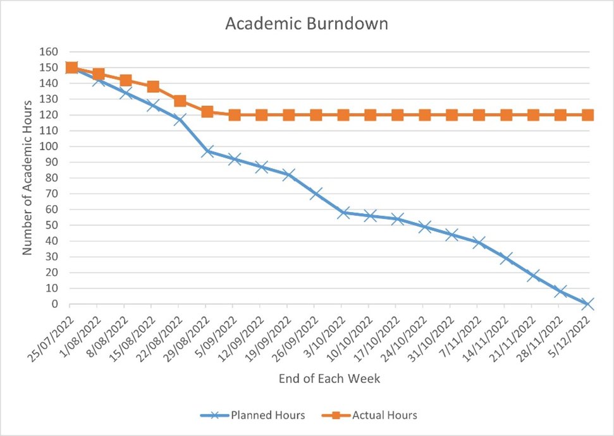

## Resources/Access Required

Hardware:

* PC
* GoPro 360 camera with a tripod,powerbank
* Smarthopne/recorder.

Software:

* Visual Studio Code
* A server (cloud-based or local)
* Lapentor Virtual Tour Software
* Adope Photoshop
* [Figma: the collaborative interface design tool.](https://www.figma.com/)

Assets and Resources required:

* 360 photos of Ara campuses
* Various pictures and icons from free sources
* Images of student Posters
* Ara Institute of Canterbury brand specifications,guidelines,map.

# Risk Management

This section will present the five main risks that are associated with the project, ways to mitigate and manage these risks to successfully complete the project.

## Approach

The chosen risk management approach is the Risk Management tool by Microsoft Corporation, which is presented a table in an Excel spreadsheet. Risk review is a very important and integral part of any project, so the review will take place after each phase, with a minimum number of revisions: 3.

The table consists of 8 main columns. Below is the information about the contents of these columns:

1. Risk Conditions or in other words the Name of the Risk (what must happen for the risk of an unsuccessful outcome of the project to appear).
2. Risk consequences. Result of the risk, should it happen.
3. Probability. The “likelihood” that the risk will happen is expressed as a percentage. Must be greater than zero but less than 100.
4. Impact. Amount of severity for project if risk is happened. In this case, it is measured on a scale from 1 to 100.
5. Exposure. Calculated automatically by multiplying two columns of Impact and Probability. Used to identify the most serious risk.
6. Mitigation. Includes an action plan to prevent or reduce the risk impact.
7. Contingency. Backup plan in case if risk became reality.
8. Triggers. Represents the reason for using a backup plan.

Top five risks table - capture

## Risk Table

# Quality Assurance

**Guideline - lead in sentence to describe this section**

## Approach

**Guideline – describe the selected approach/framework/method for maintaining quality assurance (deliverables must meet client and good practice criteria) ,why it was selected, how often the quality assurance table will be reviewed, and how to read the quality assurance table.**

## Quality Assurance Table

**Guideline – this is a list of all deliverables, the criteria for acceptance, who will accept them and date of acceptance.**

## Test Plans – Functional and Usability

**Guideline – detail your separate Functional and Usability testing plans – you will use these, update and document the results during the project.**

# Project Management Framework Methodology

This section will present the framework's chosen methodology for implementing the project and the reasons for the choice.

## Overview

For the successful implementation of the project, it is very important to choose the right framework and methodology. There are several main frameworks that are successfully used in the IT world right now. After a thorough analysis of the available methodologies and frameworks, it was decided to focus on combining Agile and Design Thinking. It is very important to choose a methodology and framework in the centre of which is the user.

## Literature Review

### Design Thinking

When creating an app or game or website - one of the most important aspects must not be forgotten it is to design a user-centred product. Companies often believe that they can develop the best solution for their customers and want to start development process before asking themselves - “Is this really what my customers users want?” Design thinking process based on problem-solving process with creativity and is the key to how new project should be started. Design thinking makes very clear that it is a bad idea to start with an assumption and build product on them before testing their validity. Instead of that, Design process teach the team focus on the people product will be created for. This will ultimately lead to better, more useful apps (Brisbin, 2019).

#### The Five Phases of Design Thinking

From these four principles 5 stages of design thinking follow. There are Empathize, Define, Ideate, Prototype, Test and the sixth is Implement, but sixth one is not going to happen until product is ready passed all stages, sometimes more than ones.

Figure 13 Design Thinking steps

While these steps may seem linear, it's important to understand that design thinking does not follow a strictly sequential process. Every step of the process can make new changes, it means that one of the previous steps/task is not relevant anymore and needs to be revised. Every step can and should be done more than once.

#### Stage 1: Empathize

Research and process the user's needs and wishes, you need to gain an empathy to a future user usually through a user research. One of the keys of this step is leaving all assumptions behind and let a customer to speak. This way you gain real insight about users and their needs (Canvas, 2022).

#### Stage 2. Define

The next step is to identify what is a problem that needs to be solved? That step is based on what have been learned on Empathise step . Problem statement identifies the specific challenge needs to be solve. The entire design process will depend on it from now on, give a fixed GOAL to strive for. When crafting problem statement, it is necessary to pay attention on the customer rather than the needs of company (Stevens, 2020).

#### Stage 3. Ideation

In this step Challenge Assumptions and idea creation is happening

The knowledge base learnt from the first two stages now can be used "thinking outside", looking for alternative ways of looking at problems, and identifying creative problem solution statement. Brainstorming is especially helpful at this stage (Canvas, 2022).

#### Stage 4: Prototype

After all ideas have been narrowed down to a few, next step is to create a prototypes or "miniature" versions of the product that needs to be tested. This phase gives a chance to “build” something touchable that could be tested on real people. It is important to maintain a user-centric direction. There are few different types of prototype depending on product and what will be tested. It could be paper prototype or advanced media prototype. Before creating a prototype, it is crucial to set a clear goal and purpose of a prototype, otherwise it will be very hard to test it (Stevens, 2020).

#### Stage 5: Test

Improve the product During this phase, by running/making tests for the product by implementing the discoveries and solutions that have been found during the prototype phase. Because it is technically the last stage of design thinking, it's important to understand that this is not the final stage where whole process stops. The design thinking process contain of iterations. What have been discovered during the test phase often leads to redefine the problems that needs to be solved. It is possible and necessary to go back regularly and review all design stages to refine the product to be as efficient as possible. Thorough testing can really give a deep understanding of a product and customer (The Design Thinking Process – How does it work?, 2020).

By using Design Thinking method natural flow is created, which makes process of idea and research to rollout faster and easier.

Dive into “customer head” can produce a very important data which can be transformed into insights, which might lead to change of a design.

https://www.youtube.com/watch?v=4nTh3AP6knM

## Critique (Pros and Cons)

|  |  |
| --- | --- |
| **Advantages** | **Disadvantages** |
| * User oriented | * User is involved |

# Ethics

**Guideline - lead in sentence to describe this section**

## Relevance of ITP Code of Ethics

**Guideline – see** [**https://itp.nz/Members/Code-of-Ethics**](https://itp.nz/Members/Code-of-Ethics) **for further information**

### Good Faith

**Guideline – the student shall treat people with dignity, good faith and equality; without discrimination; and have consideration for the values and cultural sensitivities of all groups within the community affected by their work;**

### Integrity

**Guideline – the student shall act in the execution of their profession with integrity, dignity and honour to merit the trust of the community and the profession, and apply honesty, skill, judgement and initiative to contribute positively to the well-being of society;**

### Community Focus

**Guideline - Responsibility for the welfare and rights of the community shall come before their responsibility to their profession, sectional or private interests or to other professionals;**

### Skills

**Guidelines – students shall apply their skills and knowledge in the interests of their clients or employers for whom they will act without compromising any other of these Tenets;**

### Continuous Development

**Guideline - students shall develop their knowledge, skills and expertise continuously through their careers, contribute to the collective wisdom of the profession, and actively encourage their associates to do likewise;**

### Informed Consent

**Guideline - students shall take reasonable steps to inform themselves, their clients or employers of the economic, social, environmental or legal consequences which may arise from their actions;**

### Conflicts of Interest

**Guideline - students shall inform their clients or employers of any interest which may be, or may be perceived as being, in conflict with the interests of their clients or employers, or which may affect the quality of service or impartial judgement;**

### Competence

**Guideline – students shall follow recognised professional practice, and provide services and advice carefully and diligently only within their areas of competence.**

## Relevant Legislation

**Guideline – see** [**https://www.privacy.org.nz/**](https://www.privacy.org.nz/) **and** [**https://www.iponz.govt.nz/**](https://www.iponz.govt.nz/)

## 

### Privacy/Confidentiality

**Guideline: what aspects of privacy/confidentiality practice/legislation are relevant to the project**.

### Copyright

**Guideline: what aspects of copyright practice/legislation are relevant to the project**.

### Patents

**Guideline: what aspects of patents practice/legislation are relevant to the project**.

# Reflections

**s**

## Approach

**Guideline: what is the way that notes will be taken to capture lessons learnt and reflections during the project.**

# Specifications

**Guideline - this is a placeholder to indicate you will be creating specification documentation derived from your initial low-fidelity wireframe / story board processes and submitting them in an appropriate manner here.**

# References

**Guideline – APA v7, supported by in-text references.**

# Appendices

**Guideline - lead in sentence to describe this section**

## Appendix A – Detailed Project Plan

**Guideline – work breakdown structure including phases, tasks, deliverables, time allocated, completion dates, resources.**

## Appendix B – Risk Management Tables

Guideline -Use this to give provide updates of the risk tables and other evidence that may not be suitable to display in the main report section – example of a table from WIL Capstone Project Risk Management

**Table B4**   
*Risk Issues Management - 3 October 2022*

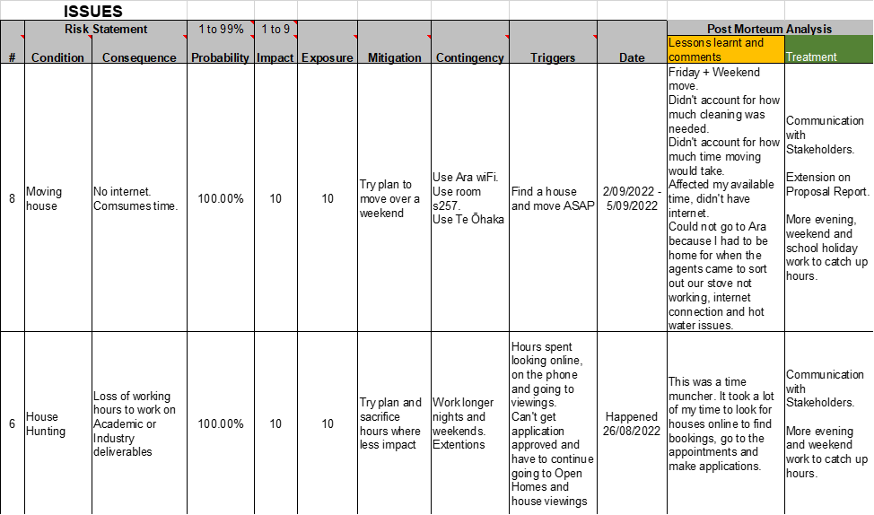

## Appendix C – Quality Assurance Tables

Guideline -Use this to give provide updates of the QA table and other evidence that may not be suitable to display in the main report section

## Appendix D – Interview Transcription and Notes

### Audio file

Original audio file can be found in **resources** folder.

### Transcript

Discover any additional information resources that need to be included in the tour or on the website. Yeah, find the target audience of interest for the product so we can produce a better experience for them. Discover the main purpose of the four for. Example is it for advertisement purposes or an informative guide and find out about you and your company to get a better. Understanding of what you're looking for.

Right.

We were going to record. This interview, if that's OK with that, we can. Using that you can record and transcribe.

More on with safety secured than about and going to destroy all digital copies.

OK, sure, fine.

OK, that's cool.

Now I'm copy of that needs to. Be given to. And for all of you.

Yeah. So you talked about.

Sure. What is what is the tour that? You think I'm going to be talking to you about?

We're assuming that it's just going to be a tour through the campus, yeah.

Is this the virtual orientation? Yes. So the reason why I asked that question is as a client I have a number of things on the go and so I'm busy, busy, busy from meetings and I just want to make sure that I'm. Talking about the right thing, so the virtual orientation. Cool, it's gone.

OK. Can you first tell us about yourself and your company?

OK. So my company have been contracted by other to create a virtual orientation experience for students.We are marketing people. We don't have the technical expertise, which is why we're getting you guys to do. The project It's made-up of myself and a team of three people who, as I said, do marketing, do research, put together the key. Messages and things like.

OK, what is the main purpose of the project? Is it to be informative or is it for marketing purposes?

OK, not to be a pain, but it's actually both. OK. So it's informative because it's going because it's going to give information and an experience to students who need to be oriented. But it also means that outside of orientation it's available for anybody to look at. And utilise so it's back.

OK. What Target's target audience is going to be seeing this virtual tour?

OK, so based on what I said before, it's a combination of students who are new to the programme. So they might be coming into the digital technologies computing programme. They may have done something, they may know a bit about other or they may not know a bit about other so. But new students to the programme. And experience tells me that those could be students that come out of high school fresh out of high school. Or it could be or they could be students who are looking to change careers. So they don't know a lot about it, but they know that they want to go into it. So there's a bit of a range there. And that I. Guess that also follows that they may some of the students may be very familiar with using technology. And maybe some mature students or students who are changing careers may not be so familiar with technology. So that means that your solution that you come up with. Can't be too complex.

Right. What devices will the users use primarily like? Will it be mostly mobile users or more like desktop?

Yeah, I can imagine it's mostly mobile, but it's likely to be tablet and iPad, desktop, laptop, anything that can go through a browser. OK. But the majority of students will probably end up seeing it on their phone.

How many people are roughly going to view this?

Just thinking about the last orientation we did. There was probably about. 50 to 100 new students. We'll we'll view it. Have the potential to view it at the beginning of each semester, but because it's marketing, it would be more as well. I can imagine that we would take this out or we would make this available to students in their last year at high school. And and do that as well. And maybe make it available. Through IT professionals or? Canterbury Tech or something like that. So it has the potential to have a large audience, which I which. Suggest to me that you could there could be a number of people using it at the same time I. Don't know if that's an issue.

Just to expand on that question, I'm just wondering you say it's from students from coming out from high school. Does this also involve international students?

That's a good point. It could involve. International students as.

Well, so would you suggest that we would have to find like some sort of translation for students have difficulty understanding the English language?

I think. Translation is is on the list of requirements, but let's prioritise it a bit lower. Let's get the content sorted and the look and feel sorted. But as you're doing that, think about is there any smarts that?

I have no idea how that how, whether you have to hold.

You can put. In to do with translation, I have no.

Idea OK.

The text in different languages or whether you would just make access, you know how how you can go on onto a website. And it says do you wanna translate this from Japanese to English? And that's? I assume that's a Google thing. OK.

Do you have a particular like look and feel of the application?

So. So we're talking about a virtual tour type concept. So that means that. Look, they it looks and feels as if they're on campus, and if they can move around on campus. And that there will be, I mean the the the typical things of a virtual tour there could be. Places of interest. That would be places that that would be that we can link in resources to do with that place of interest. So maybe we might say a place of interest in the virtual tour. Is enrollments. And so when they when they go to enrollments in the location then. I can imagine that they might have access to the enrollment form and the the website and the programme handbook. About things. Maybe when I go to. The reception area or the home of the IT programme? Maybe I've got an ability to see the faces of the tutors. OK. A timetable, something like that. As well. So it's yeah, OK.

You see that you'd want to maybe be able to click, click, and go to the website you're talking about our website, right?

Or any other relevant.

Websites. And do you? The colour schemes to be similar to the rural website.

And might be something. Else you want to think about. In terms of the way you organise. The information. You will need to have, I'm sure. With the landing site. Before you take people into virtual.

Yeah. Thank you, David. Yeah.

Environments, right? So you, you'll need to be thinking about how you construct that as a starting point so that people can then choose to get the information and to see things that are appropriate. I'm going to talk about this. A bit more, but problem marketing. Is what is the cool stuff that people do? In the BRCT. Programme. Yeah. OK.

Let's link. Let's link on to that. Let's launch onto that. So as part of the virtual orientation, it would be good if the people going on the tour could have access to work that students have done in the past. And the way that we show our work in the past is with posters. So there is this thing called an Emerge exhibition, which happens at the end of each semester where third year project students. A A poster and A1 poster and a short couple, a couple of a short paper, which which is a real showcase of what they've done, but also what our students can get involved with so that so that takes us more into that, that idea of the marketing side of it. So maybe maybe in the virtual tour they go to a location which is, I don't know, showcase or emerge exhibition or or something. I'd like you to sort of think about this where they can see the posters.

What about accessibility? Do we have to like for example have a high contrast mode for people that have vision impairment? OK.

So so I don't know the specifics of all the accessibility, but. The more people. That can utilise it. The solution? The more chance we have of reaching them as potential students and helping them as orientating them so 100%.

Do you want it to be like free Rome, or do you want it to be structured?

Just just give me a little bit more. What's the difference between free?

Runs and like the users can go in whatever order they want to anywhere. Or is it like we are making them go through some track?

Free run.

So do you want like a? Map 2D map of click on those points.

I to be a typical user, I actually want both want both. I want my I I I want the free roam so it's just it's just like a a game. We want story mode. But we want, we want. We want. Free roam as. Well, because the the story mode or the structure is that, hey, I'm. A new student. I'm going through orientation. There are certain places that we want them to know about and therefore I want them to go with that. Now I don't know if you can do that, but then there's also. I want them to be able to free roam so they can go and and drill down further. Or something like that. So so both as the ideal, but you give me feedback. When you're working on. This as to which one is easier. OK, they're both easy, OK.

So where would you like to start? The virtual tour? Is there like a particular place?

That's a good question, David. What do?

We consider the entry point for.

And there are. More than 9. Gate entry points, whatever. People will arrive at Para from different directions.

OK.

You need to be thinking about how you might give them. Appropriate virtual start points depending on where they choose. To arrive, and if so, you might. Choose the main gate #7, but then up here. We've got gate number. Nine. And then you've got. Out the back with the student car parking a. Little more house. You might have some key places that will. So where are you going to arrive from? And when I click on it. That's the starting point, yeah. Where you where you're trying to get to. From there you know you you you need to think about that are. You are you going to live? People an appropriate starting book because not everybody. Just as you know out here in game #6 and walks into the main entrance.

At this point.

And we don't. Going forward, we don't we we don't know where our hub or our home is going to be for the ICT programme. OK, it's currently it's in the. Place that you guys are familiar with where Sandy and meeting normally, Sir. But that's not gonna be the place.

It will move.

It will move, so if we.

Absolutely. Moving, yeah.

So if so, if we want to use this beyond what you create and and use it going forward, then it needs to be a bit flexible about that. So yeah, cater. For all the all the multiple entry points.

How much of the campus do you? Want to be covered?

Yeah. The main facility, the the main area, the main. Facilities which which? What map have you got there?

Oh my goodness.

Got the point here, everything.

What I'm going to say is that we've done this orientation just recently and we put them on a scavenger hunt to find different places come to me and I'll show and I'll show you that map. Yeah, OK, I'll. I'll show you. OK. I think I think the real answer is not everything. Here will be key things, but we want to be flexible enough because we're starting to teach in different locations. That we haven't talked to taught in the last five or six years, so. We almost need a map, but a map which has certain locations, so I'll make a note and I'll give. You the orientation then.

thanks for not everything. Yeah.

Is it like the orientation design for some specific courses or is it like for everyone studying at ARA?

It's for every it's in the middle, it's. Everybody's. Studying in the ICT programme so it could be diploma students or degree students, but it's only in that area, OK yeah.

Is there any information you want us to like show in the virtual tour of FAQs? Student residences?

Yes and yes.

OK.

And I don't have a complete list so. In my head at the moment, but I'd like you to think about so again, we'll OK. So I'll also make a note to ask me for what we included in the orientation pack. So we have a series of slides. So that will give you an idea of what orientation capped as well. But also I want you to think about yourselves as students and what you think is important, so utilise your own experience because that would be useful for me.

That concludes the.

Yeah, I know. I teach you to ask that question. But it's a really hard question. I'm gonna. I'm gonna turn it back on you to, to be fair. Do you have enough? OK, first of all, what is the next step? You're gonna come back to me. Give me some stuff. But what's the next step when you? When? Will you come? Back to me with something.

In the weekend. Often for us, there's no you're doing. After we finish the log file.

And the Lofi prototype.

I suspect that you will be wanting more specific orientation information and lists of things from your client. By the end of the. Week so you can start to actually. Thinking about and leading yours. In your write ups.

All the information. You require beyond that orientation map.

We will be making available. Those folder in the E311. And in that we'll put 2 examples of what has been used for orientation in the past, including the PowerPoint and the maps and things that were relatable. To the students.

Yeah, and the emerge posters.

And the the image person, I think that. That's a big base, but what we'll. Do is review the ones that were made available. This different conference probably is a subset of. A place to start because this is a. Proof of concept.

Yeah, going off that that it's a proof of concept. So we. Can't we don't have enough time to deliver? What? You know everyone would like, but azuni stretch goals.

That if we.

Do have time. Like would you like?

Does it? Can you do searching? Keyword searching.

What about loading? New virtual tours on top or new posters? For strict yeah.

Yeah, that's a stretch goal. Yeah. The ability to rather than coming back to you and saying can you load these posters being? Able to do it ourselves. Yep, sure. So when I come back to when do? I get to see something. Do I see lofi?

Yes. Yeah.

OK.

And they are happy to give you their love for stuff.

Yeah, not good. OK. So I'd like to treat this, that you that you. You keep me in the loop along the way so I can see what you're putting together. So if there's any corrections or any not corrections as you've done anything wrong. But if I come up with any ideas. Or you guys? Have come up with some amazing ideas. Then we can. We don't need to wait until we get.

Let me reiterate processes. This is a group activity. With regards to your information requirements. Would be a group opportunity with regards to assets acquisition of what each one of you produces is your individual interpretation. And So what? The client is. Going to get. Is 7 interpretations.

All right.

Which is great because then because they would. I I hope that will give me a variation. Rather than 7.

Know what he might say? So I don't remove them.

I don't want seven things exactly the same.

Yeah. What you work on individually? Is important.

So it's your.

If what you think. There will be. Some hearing amongst the group because there will be some. Technologies that you'll be. Using in common, perhaps in terms of how do you make things happen? What do you do? What you make happen is your interpretation. Yeah, yeah.

Just, just just. To reiterate, this is a wrong play, so I'm not full up the IT person. I'm not Phillip the tutor. I'm Phillip, the client. OK, so and what I said at the beginning is that you guys are the experts from a technical perspective. You may not feel like experts, but you are the experts. I'm the experts from the content and the fact that I want to. Market it and I want to. Look after my students and all that sort of stuff. And deliver a solution to ADA but. Don't assume I know things technically.

OK.

Also, I forgot this question but. How old browsers do we have to support?

I don't know how old, but all the common browsers Chrome and reset the edge and. Firefox, all the all the common.

The most important question how big is the budget?

How big is the budget?

Thank you.

Yeah. Work for prayer.

Getting a qualification out of this? So priceless. Priceless. OK, so, let's see, we talk about locations, resources, target audience. Main purpose in the company. Yep.

OK, OK.

Thank you very much for your attention for your time.

That's all right. Thank you.

Maybe you have any questions do you have? Any questions to ask? OK.

Just deliver. Deliver me something amazing.

Oh, yeah, what's your e-mail?

You can find it.

It's a standard format Phillip dot boxberg. Yeah, that's that's the e-mail.

Could be a different e-mail.

Would be using.

Alright, are all phones.

Turned off now.

**END OF INTERVIEW**

Notes from Interview.

